Writing Portfolio
Emmalisa Horlacher
ENGL 218
Shamae Budd

INTRO
At first my goal was just to revise the pieces I had previously submitted. As I was looking at them I had a realization. I know I could have reworked different parts, and changed words here and there but I also realized that had I done that, the original aim I had for each piece would have been lost. For instance, the poems I had originally created were solely for the entertainment of reading. I love things that combine sounds that are similar to create a feeling or cadence, almost like lyrics for a song. I realized that at that moment, if I had tried to change up the poem to add more depth I would have had to lose my cadence. To me, it was a finished piece. It may have been just adequate work, but it was adequately finished work. This is not to say that I won’t come back later and mess with the cadence and depth, but for now, those were not the pieces where my heart held potential.
For the creative writing section the things I ended up choosing and revising were things I had written after we had gone through the section. They were things inspired by real life but adding a fictional twist. Similar to my original pieces, I still tried to keep humor the focus. All semester I had been joking that my math class was my boyfriend. I noticed that I was able to get a lot of people to really laugh at that concept so I took the jokes I made and turned it into a standup-routine. I didn’t like it and the thought of performing it was anxious. I wanted something I could give to my math class that they would relate to and laugh about. So I kept the jokes I had come up with and created an end of semester tribute to my math class, hence the dear john letter. Since math isn’t my major, I thought making it a breakup letter would be fun. The second piece was written over the course of a few mundane hours that I had at work and was originally going to be the script to a short youtube animated series. As I was trying to revise some of my other pieces, I didn’t like them, so I revised my script to make it more reader friendly rather than visual based. It still contains visual aspects but now the writing is what interacts with the characters, not the narrator. It was an interesting concept to explore, how written text interacts with pictures on a page. I’ve read it to a few people (as it is still more of a performance piece) and I feel like their reactions are one way that I get feedback. If they laugh, I know that the joke has hit, if they don’t, I know that I still have more work to do. It has also helped to get the flow and words right, while it is supposed to be awkward, it should still be an easy read.
Within the poetry section I decided to experiment writing a free verse poem using imagery. I had the words, “sight, sound, touch, taste, smell” typed out on the page so that I could remember what my priorities were. I wanted to pattern my poems similar to the type of poems we read in class so I tried adding more symbolism and phrases with meanings that aren’t clearly defined.
Finally, the essay has been a long haul type of project. I’ve found a lot of worth in working on it. Lots of tears shed too. I took my professor’s advice and printed it out, cut it out and reworked it to create a different order of paragraphs. I tried to make it more chronological and then I put all the parts relating to the experience of my Grandfather’s passing towards the latter end of the essay. One of the comments of feedback I received were that I needed to make the “obituary section” less “obituary” and more experience based. I realized that the obituary was my experiences but that I wasn’t properly conveying that so I worked more to add why I highlighted those specific snapshots of his life and what they meant to me. I still kept a lot of the “obituary” type language, just added more personal language too. The second piece of feedback was that the ending needed to satisfy the feelings within the piece. To do that I fleshed out the ending more and I added another experience that I had. I hope that the essay still flows well because I worry that without the drama of the death scene at the beginning, the audience will get lost and bored. I also tried to reduce the redundancies and improve clunky sentence structure. I never know how to feel about clunky sentence structure because sometimes I feel like it is more natural than perfectly phrased sentences. But, my audience is number one and I want to make sure that they have a great reading experience which can mean that I need to change a few sentences so that they won’t stumble over my words.
In each genre I aspired for a different aim. In the poetry, I wanted it to be descriptive and almost mysterious. In fiction, I wanted it to be comedic and in the essay portion, I wanted it to be real and blunt. As a writer, I want to write things that are entertaining but carry depth. In each piece I had an aspect of that goal. As I was revising these pieces those specific characteristics are what governed my decisions. For the fiction, add more comedy and less story. Make sure the story is so simple that I could explain it in just a few sentences, that way I can use a narrator’s metacommentary to give more silly insights about the characters. For the essay, I wanted to be real to how I was feeling in the moment. That also became tricky because as time passed, so did my feelings. I didn’t carry a lot of those same hard feelings after a while. It really was very healing to write about actually. A lot of the essay just needed a few tweeks here and there, making sure I kept my tenses uniform and what not. Overall, I felt like I was able to grow my ability to write deeply, descriptively and comedically. Now I feel like the next step in my writing is to try to combine all those aspects together to create something entertaining and deep.

FICTION
A Dear John To My Dear Calculus Class
Cal,
I am so grateful for all you taught me this semester. Being together has really shown me how to ask for help and reachout, however, I think it's time we end things. Now I know you and you're probably asking why. You probably don’t realize how hard it was for me to understand you, how I didn’t feel respected, and how, with you, there were always problems.
You always did want logical reasons for everything. So let me tell you my reasons for breaking up:
First off, I will be brutally honest. You did not respect my boundaries. You claimed to be a full supporter of rules and boundaries, but truthfully, I think you would just make stuff up or move things around just to get the answer you wanted. You were always trying to push the limits, “define the limits”. You told me I was infinitely blowing things out of proportion. I told you where I stood on things and if I’ve told you n amount of times, I’ve told you n+1 amount of times. But would you listen? No. Which leads me to my second reason: Communication.
Cal, our communication was awful. There were so many times I felt like you were just making up your own definitions for things. Take “Riemann sum” for example, is that even a word? I felt like I had to learn a whole other language in order to talk to you! And deciphering your body language was like trying to decipher a graph; and boy, you have more curves than I do. Sometimes I felt like the only time you would listen to me was when I was trying to simplify things. It was rough. You don’t understand how my friends and family were very worried about me, they considered holding a convention.
Lastly, you were always creating problems for me. As soon as I'd think we solved something, or I'd finally gotten it right, you'd add another variable. You always kept telling me that there was something differentiable between us. You'd say that you just wanted to "optimize our relationship", "derive the source of our issues", see if you could "find a root" or something. Cal, as much as you'd like to believe it, those are not integral parts of our relationship. Not everything has to be squared and sometimes, I'd prefer it if they weren't.
I used to appreciate how you’d always try to equal things out between us and make sure we were both even in our efforts, but what you demanded, it has just become too much for me. For instance, I knew that you had dated previously, but I didn’t realize how many of your Xs I would have to be dealing with. I think you need someone who will appreciate your Xs more than I do.
These are the main reasons I believe our relationship is discontinuous. Our problems, communication and unbounded relationship has just become too much for me. Yes, I do remember your last effort when you wanted to do a final examination on our relationship. The truth is that I only agreed to it because you wanted to. But when you told me I was just barely passing, I was mad. I want to wish you the best. You truly are a grade-A kind of guy, and so I hope you’re able to meet someone someday who fulfills your expectations and requirements, but I’m sorry, I just don’t think I’m her. Good luck, and I’m glad it’s over.
Love,
One of your X's
P.S. Thought you should know: Our dates to the math lab were always a little less than romantic.
A Series Of Related Flash Fiction Fairy Tales:
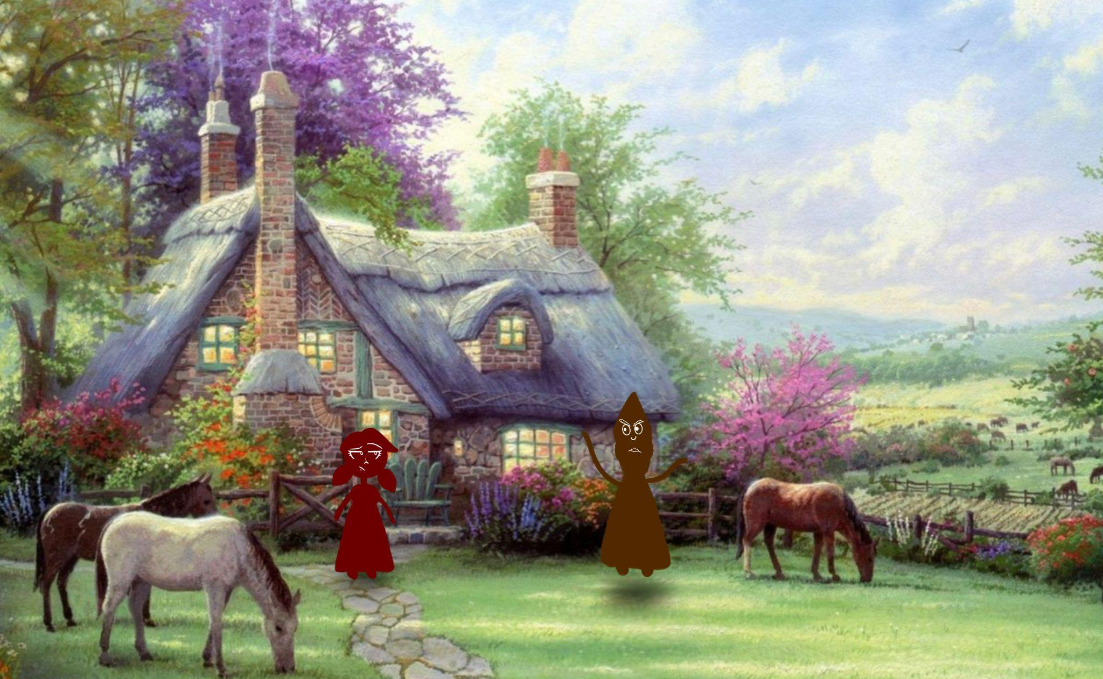
THE CURSED MAIDEN AND THE BOY. PART I
Once upon a time in a house by the countryside, there lived a beautiful maiden. There was also a wizard in the country. The wizard came by sometimes to pet the horses and stuff but truthfully, it was because he was in love with the maiden. Also he had nothing better to do because magic was considered a black-market trade and nobody wanted to buy stolen goods.
One day, the wizard proclaimed his love for the maiden. He gave a beautiful heart-filled speech, full of his undying devotion to her. She only listened to maybe a portion of it before she said, “Nah.” Flat out rejection. Not even a full sentence.
The wizard, who had never gone to anger management therapy, cursed the maiden, to never be able to fall in love ever.
“If you won’t love me, then you’ll never love anyone!” The wizard said.
Years later he’d look back on that moment and realize that the problem was probably that he was just too old for her, but, nonetheless, in the moment, age did not follow wisdom and the maiden became cursed. Then the wizard flew off, hiding his face in tears with the whole “ugly cry” thing going on while the cursed maiden bemoaned her existence.
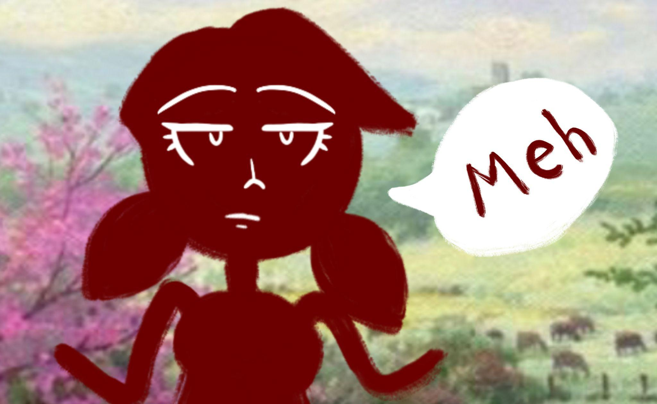
Okay, well, actually, she was kind of indifferent about it and went about her life as if nothing had changed. But things had changed. But only a little. Because the wizard who used to come by often, no longer came by to pet the horses. To be continued…

THE CURSED MAIDEN AND THE BOY. PART II
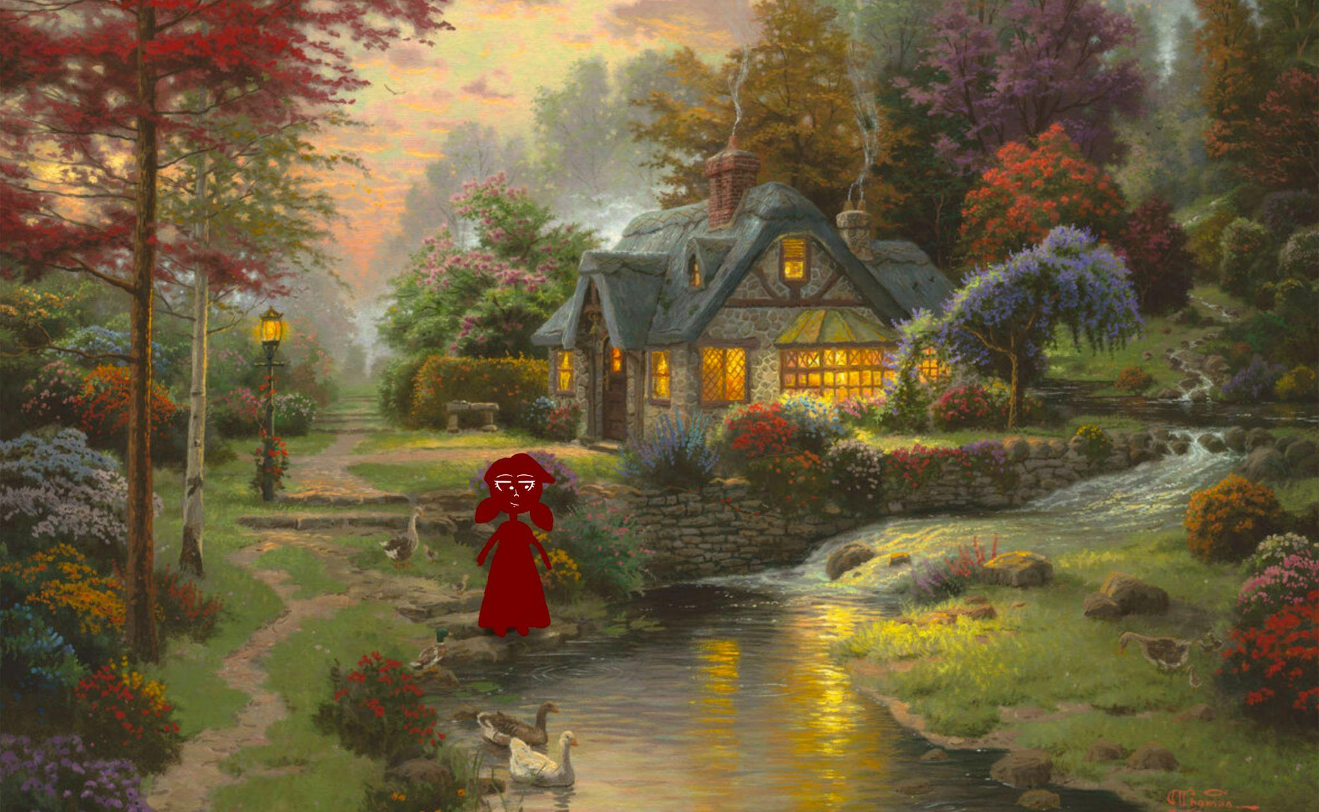
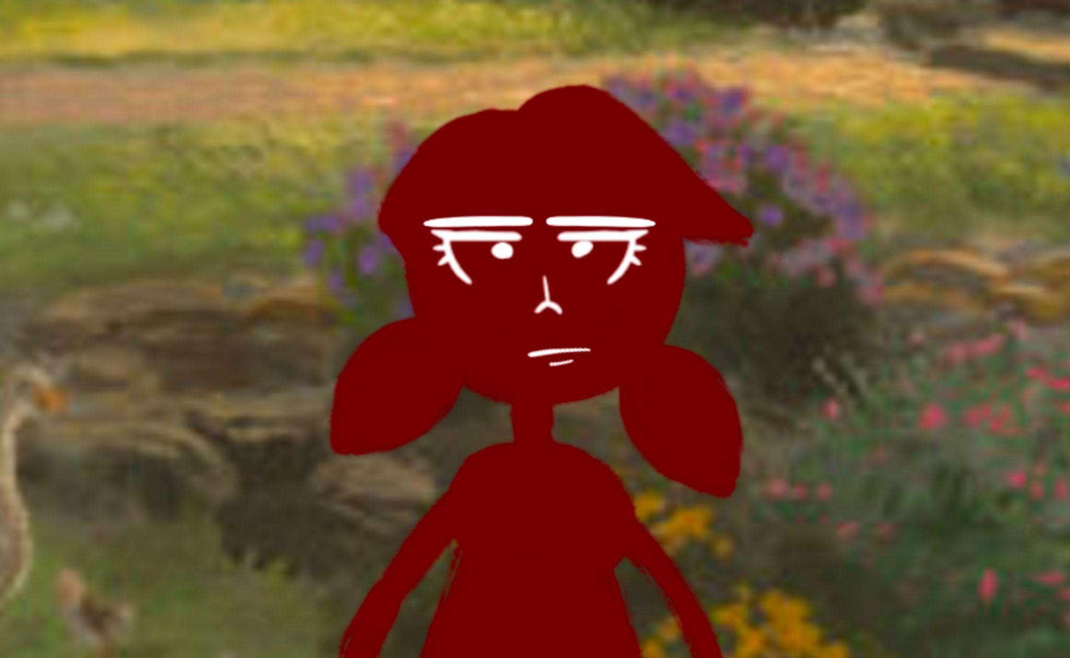
Once upon a time there was a house just outside the woods. It was a cute house with a stream by it and a lamppost and some ducks, maybe some geese. No one really knows how the lamp was lit, fire, electricity maybe. Did a person light the lamp, was it magic? It’s hard to be sure. All this senseless talk made the maiden impatient so I should probably move on. But man that’s a nice lamp.
Ah, ahum, right. The one who lived in the quaint cottage was a beautiful maiden, but unfortunately, she was cursed. Cursed to never be able to fall in love. But that didn’t matter to her because she liked to feed the ducks. And go on walks. And smell the flowers. She would have been in love with the smell of flowers if only she could fall in love.
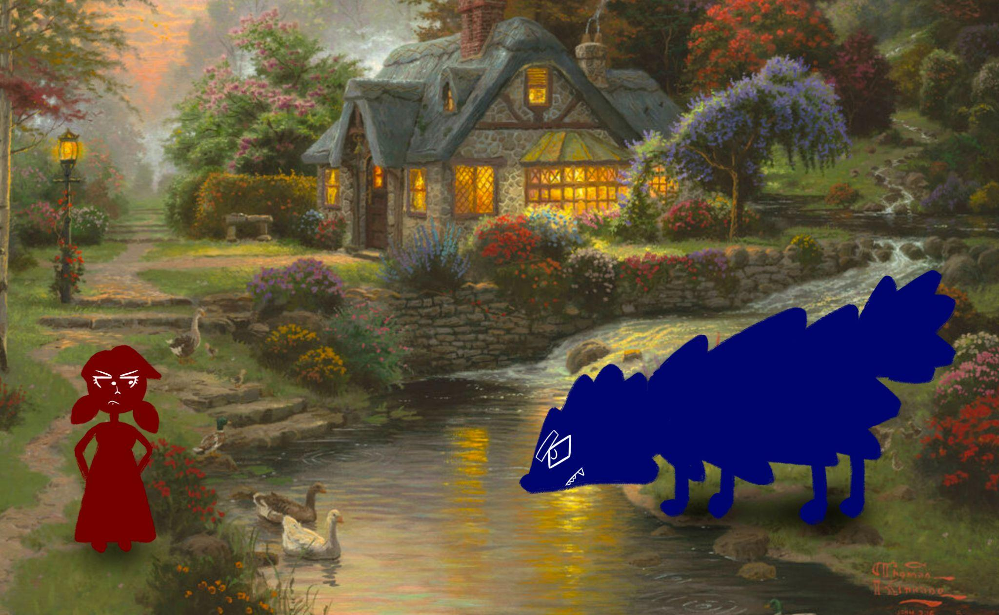
The maiden herself is what is defined as a static character, which means she doesn’t instigate events, which means her only redeeming quality is that she’s beautiful. To keep the story interesting, stuff has to happen to her and on this day she was approached by a large, scary beast.
She thought for sure she was going to die.
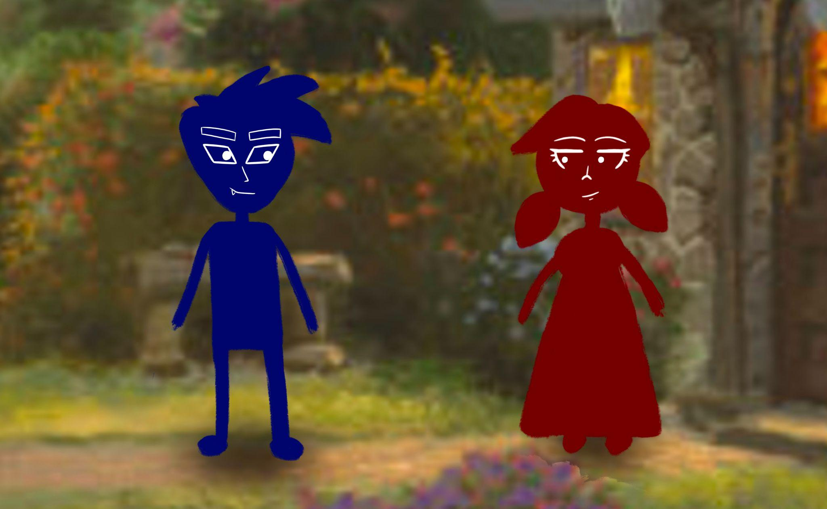
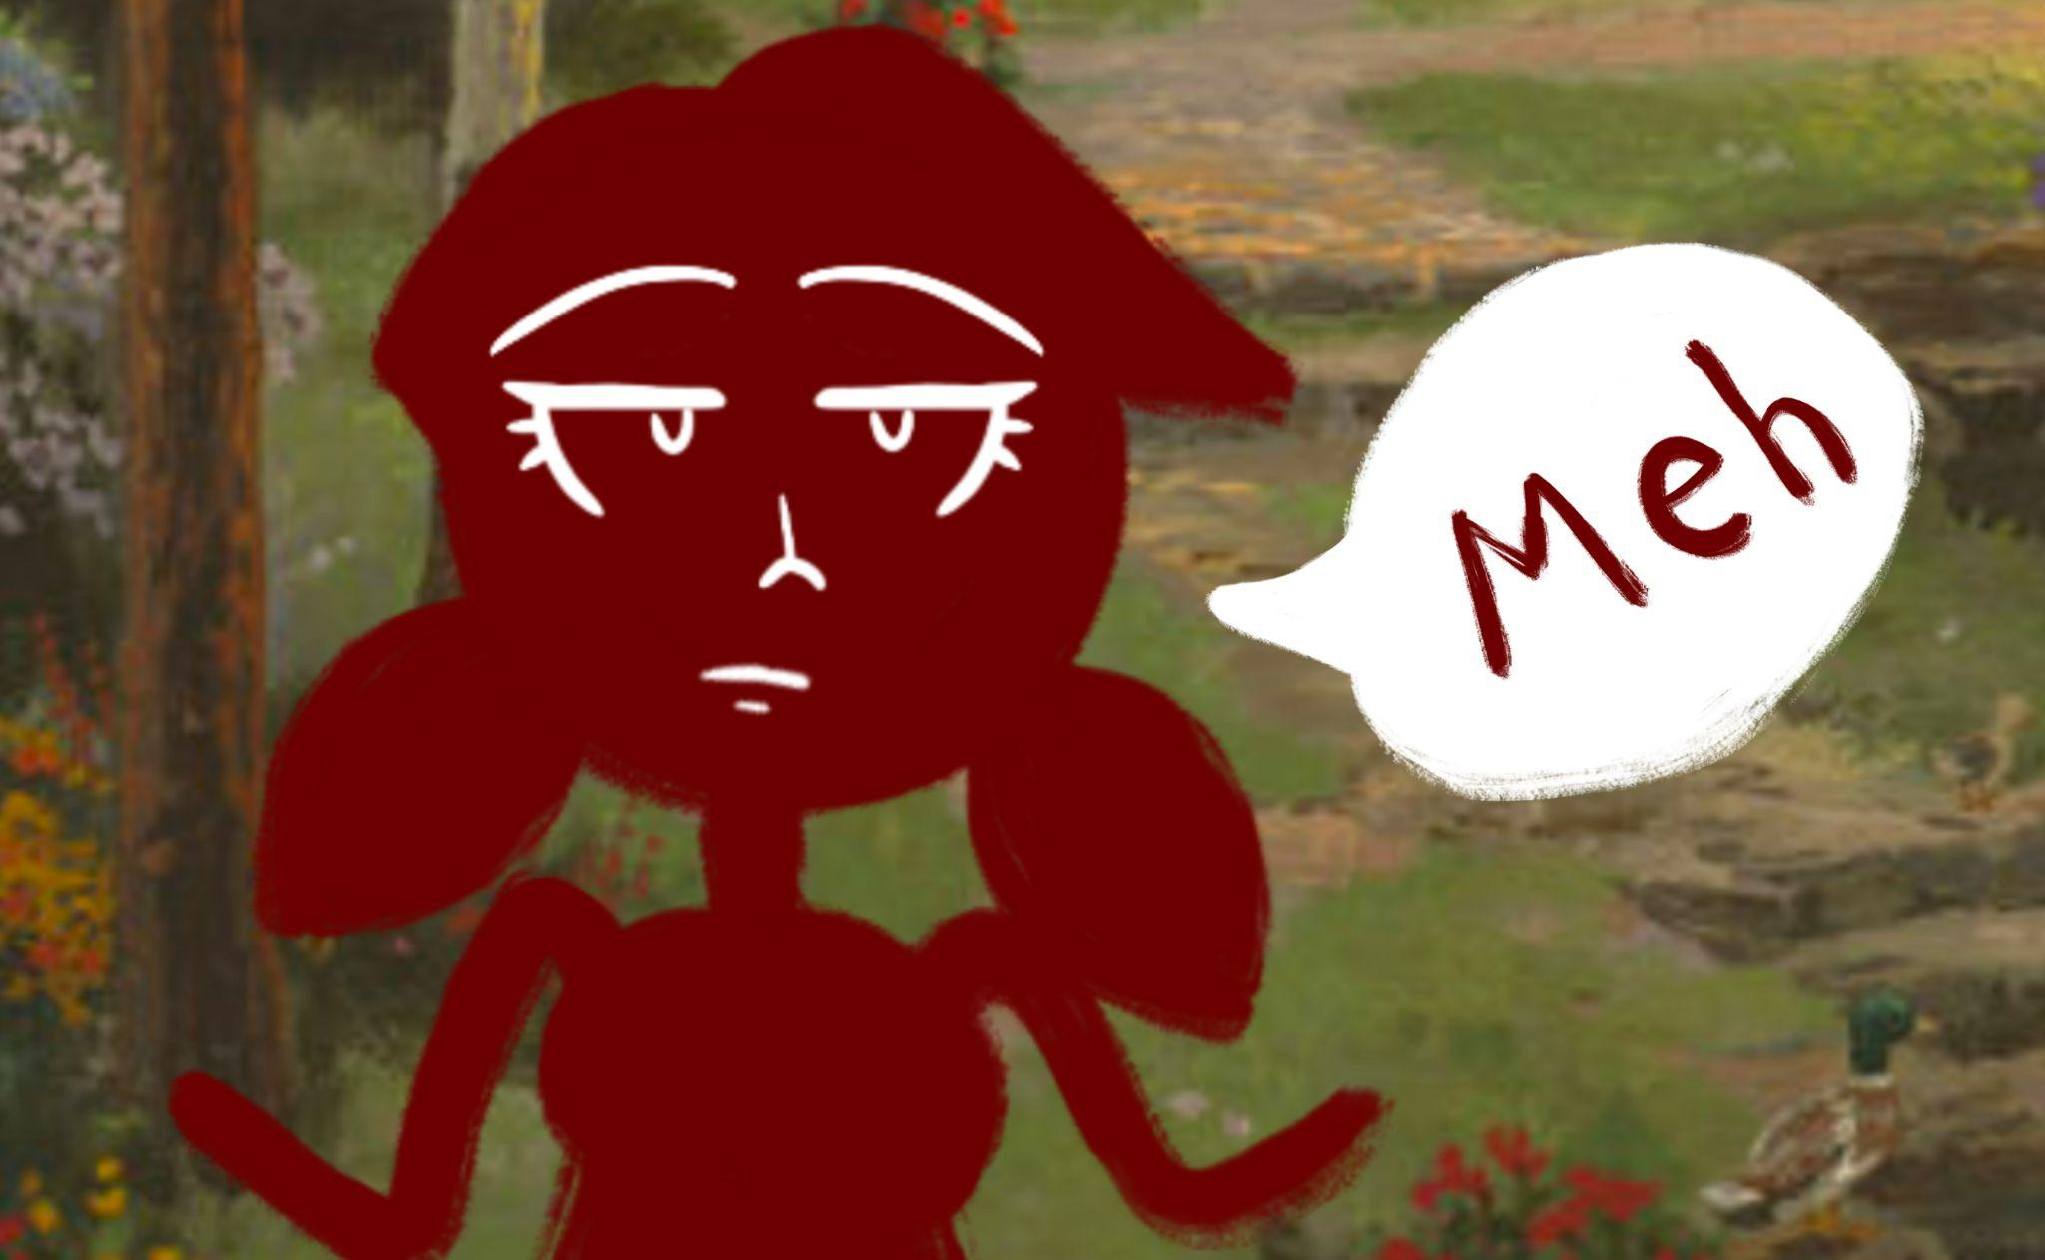
Well, actually, she was kind of indifferent about dying as lots of people in her life had died so she thought, if they can do it, maybe she can too. But the monster didn’t attack her and so she didn’t die. Instead the monster went to eat one of the ducks but the maiden didn’t want the monster eating one of her ducks so she said, “If you’re hungry, I’ll cook you something. Just don’t eat my ducks.” and the monster obeyed. He didn’t think she would go inside and come out with a shotgun. But that was a good thing because she didn’t come out with a shotgun, she came out with food and fed the monster some of her dinner. Then the monster turned into a boy and the boy explained that he was cursed. Whenever he got angry, he would turn into a big monster. The boy and the maiden realized that they had at least one thing in common, they both suffered from getting hangry, so they became friends. Also they were both cursed.
To be continued…

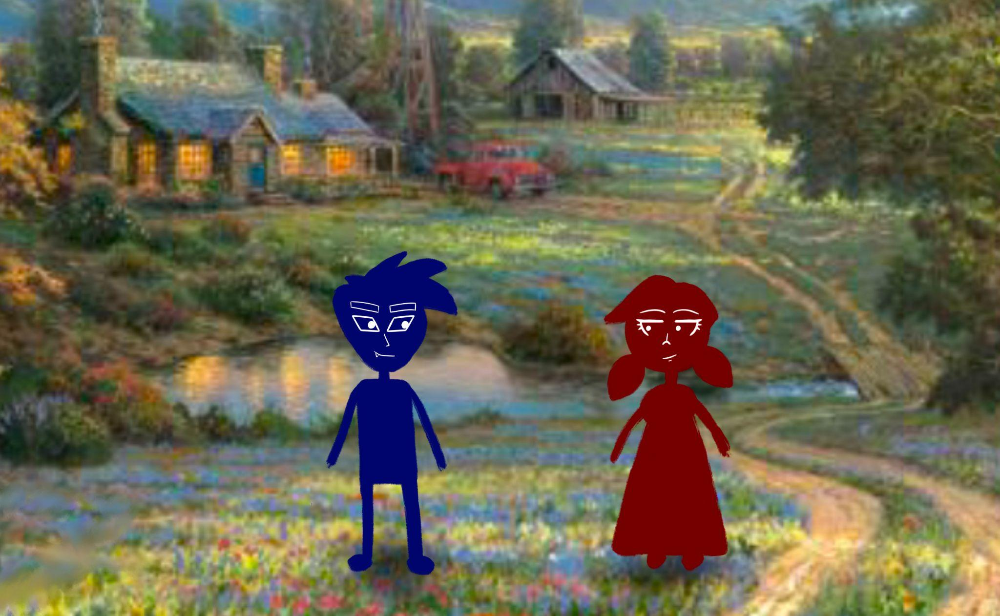
THE CURSED MAIDEN AND THE BOY. PART III
Once upon a time there was a house on the prairie where lived a beautiful maiden and a boy who was basically a man if he could grow more facial hair. Unfortunately, they were both cursed. He turned into a monster when he got mad and she could never fall in love, which was extremely unfortunate because the cursed boy was totally her type. Because they lived on the prairie and not somewhere secluded like the woods, they had many people pass by. On one occasion, a great Lord passed by. He saw the maiden and immediately fell in love with her, because he was just that kind of guy. Since then, he came by the house often to give the maiden flowers. The boy, who was about 65% sure that he himself was in love with the maiden, debated on being jealous…
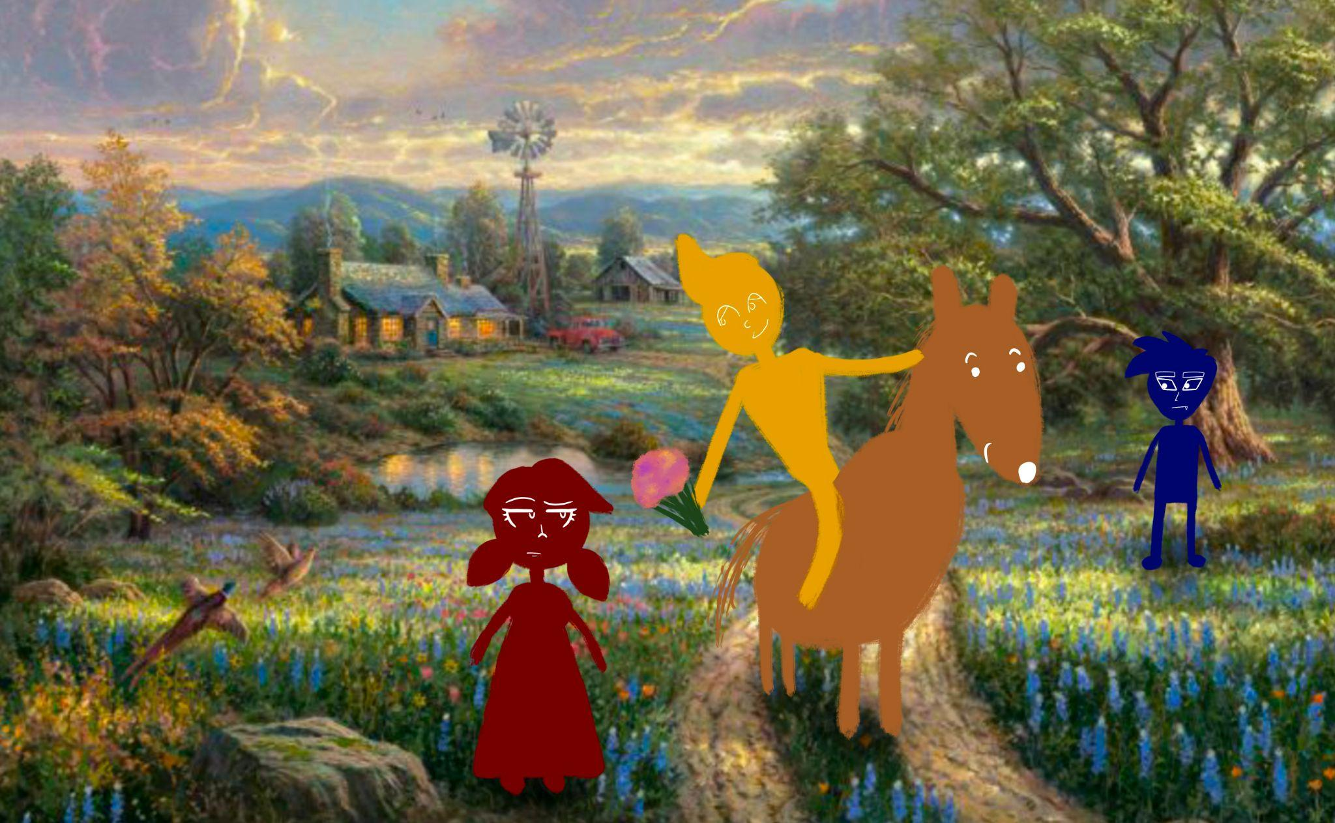
“Are you jealous?” The maiden asked the boy after the Lord had left.
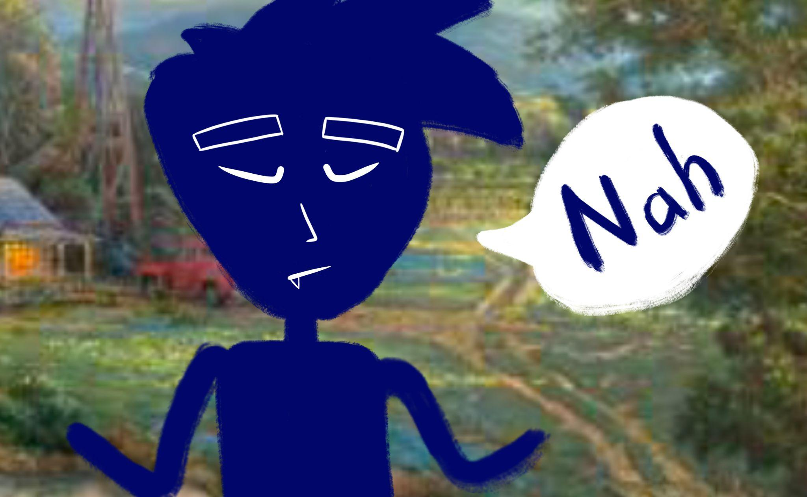
In typical, nonchalant fashion, similar to how the maiden would respond, the boy said, “Nah.” And if the maiden had the ability to fall in love, she probably would have fallen in love at that moment.
The Boy was happy he decided not to be jealous, because if he had been jealous, he might’ve turned into a monster and been hunted by the Lord. Instead, he threw a rock at the Lord, who fell off his high horse and landed on his head which caused him to have amnesia and completely forget about the maiden. The Lord stopped visiting after that. To be continued…

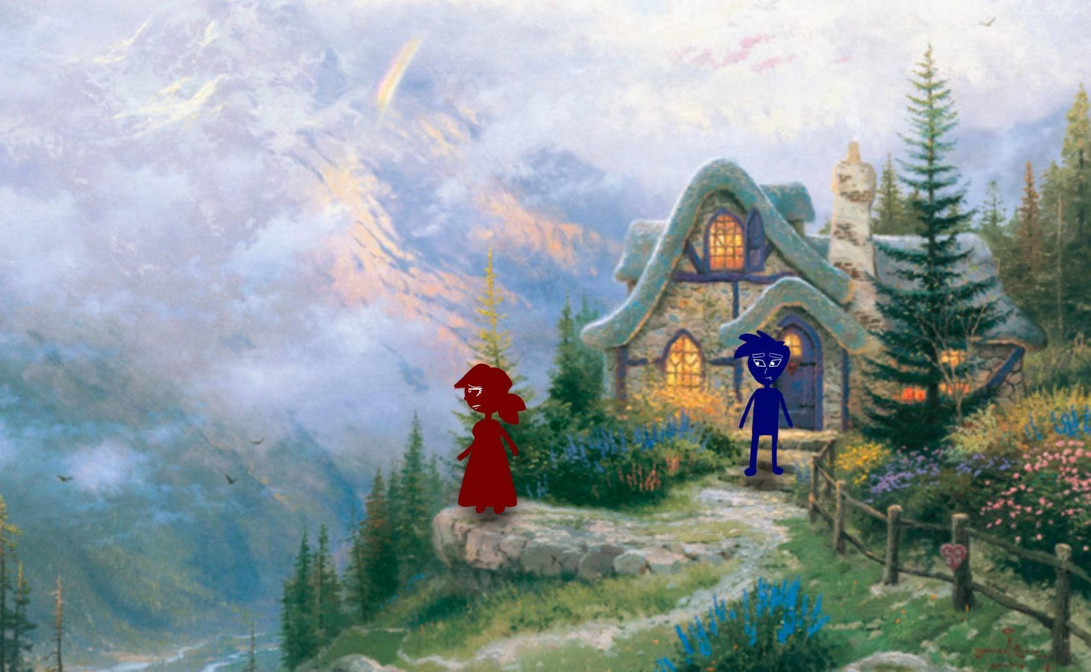
THE CURSED MAIDEN AND THE BOY. PART IV
Once upon a time there was a house on top of a mountain side. This house was home to a beautiful maiden who had always lived there her entire life and had never lived anywhere else ever. Also a boy lived there too. And they were both cursed.
The mountain side reminded the girl of her family who had all gotten the plague and died. She would have felt sad about it but she was cursed never to feel sad-wait no, she wasn’t cursed to never feel sad, she was cursed never to fall in love so she definitely had the ability to feel sad. So she felt sad about how her family had died.
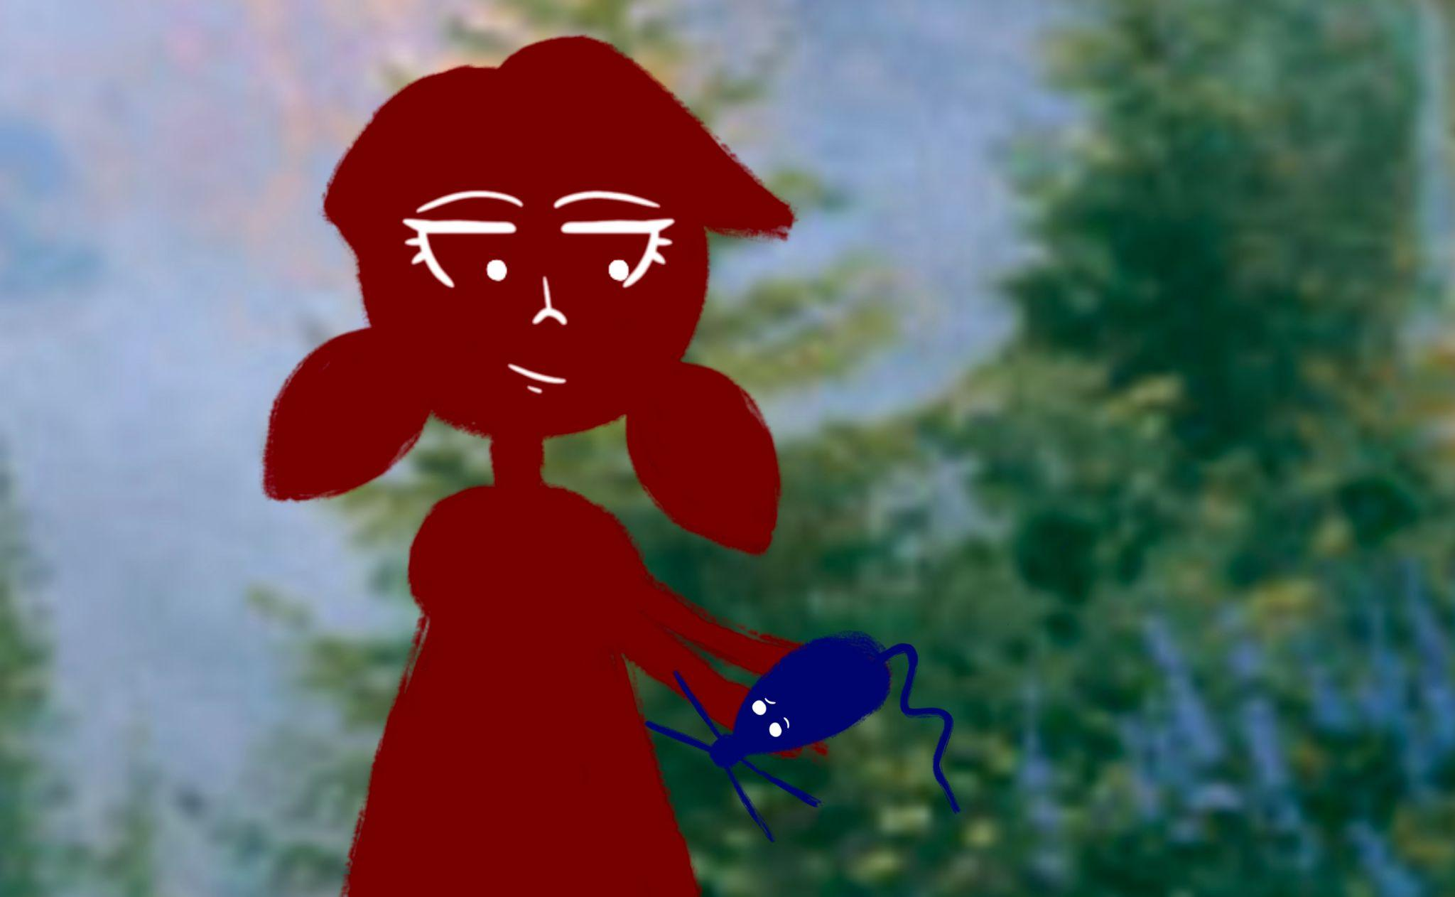
The boy tried to comfort her by singing… but he was a very bad singer and got angry when he couldn’t sing well. Becoming angry made his curse activate and he transformed into a monstrous beast…
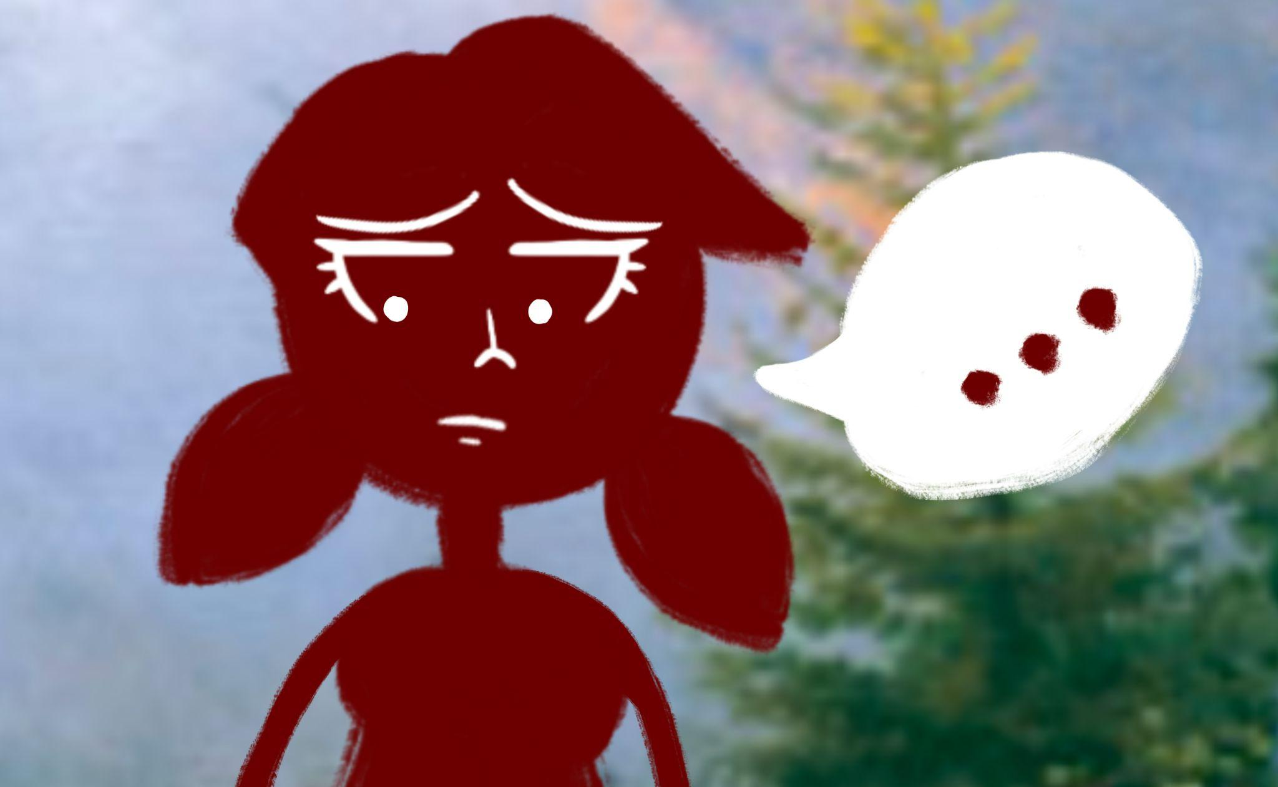
Yup, that’s probably right. The maiden and the transformed boy went inside to make hot chocolate because it was cold to live on the top of a mountain. It was then that the boy decided to leave the maiden so he could take anger management classes to help break his curse. If the maiden was in love with the boy she would have felt sad but because she was cursed to never feel sad-wait, she wasn’t cursed to never feel sad so the maiden did feel sad about how the boy left.
Yup, she felt sad. So she waited in her house on the top of the mountain side for years and years for the boy to come back. To be continued…

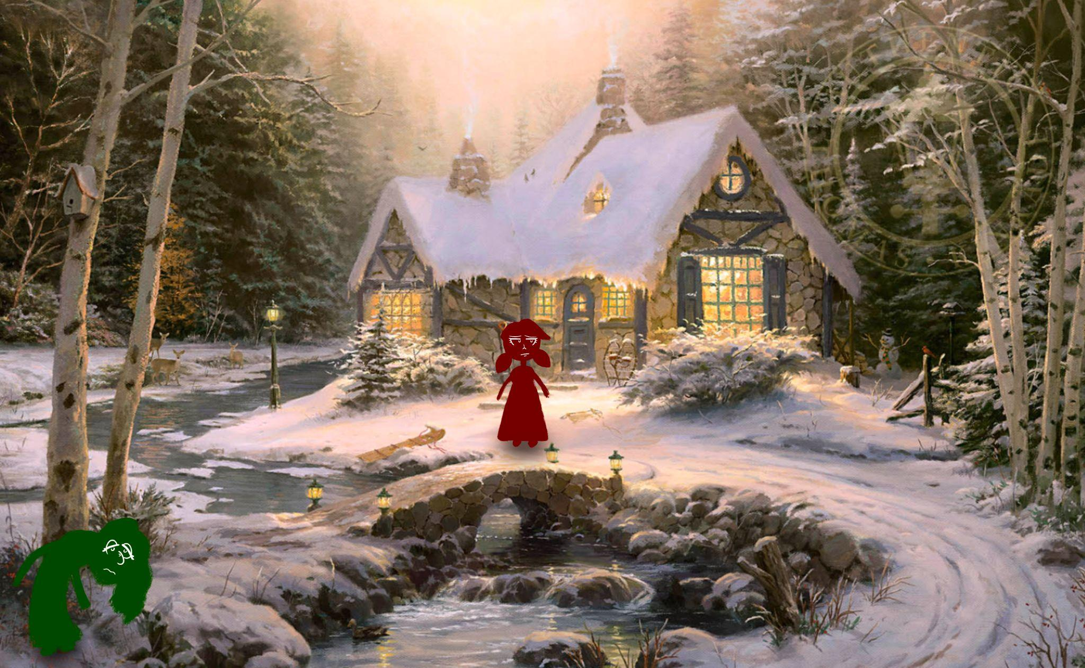
THE CURSED MAIDEN AND THE BOY. PART V
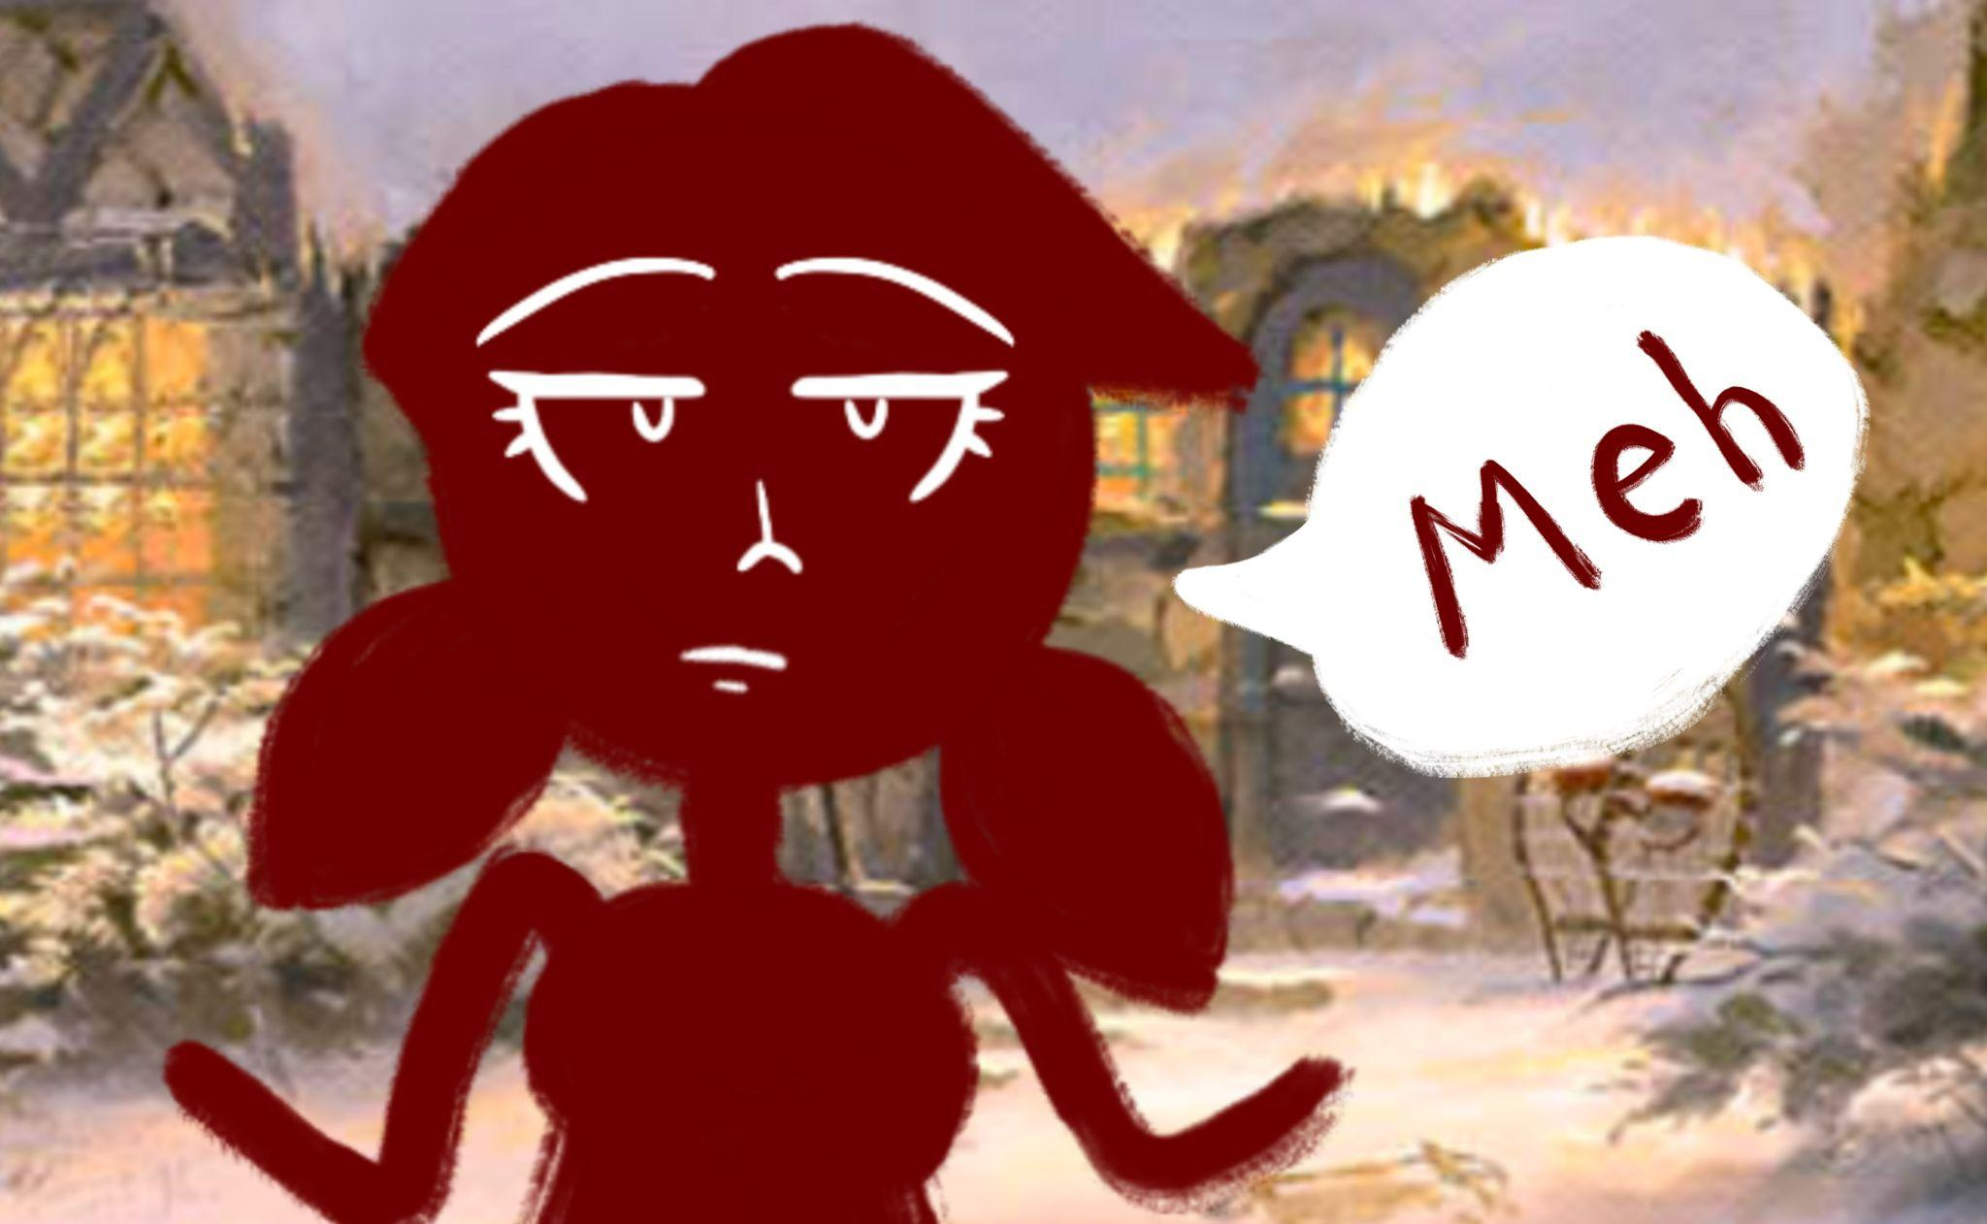
Once upon a time there was a house seated in snow because it was winter and winter was the only season invented at the time. A maiden lived in that house and she loved living there.
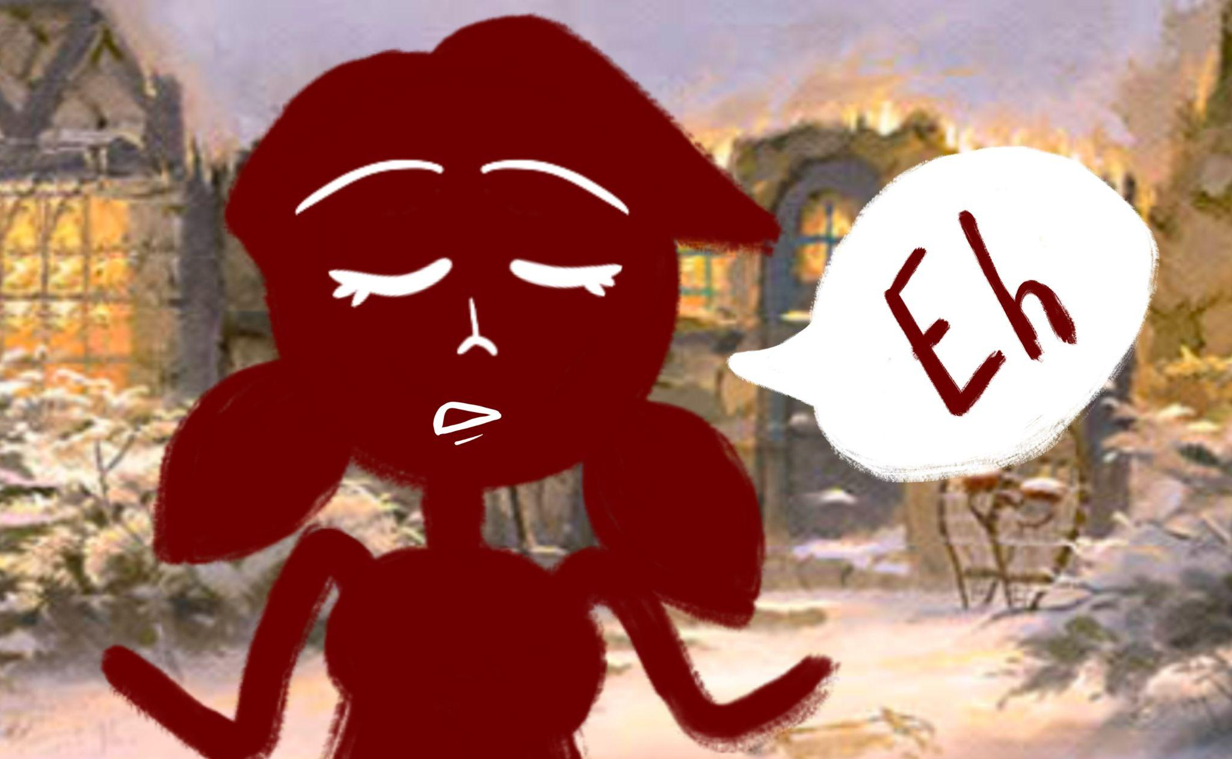
Well, actually she was kind of indifferent about it because she hated the snow.
Well, actually she was kind of indifferent about it really because she was cursed to never be able to fall in love. Though now she wasn’t certain if the curse was real because there was this boy, but he all up and left her to better himself for her or whatever, and she was maybe kind of waiting for him to come back or something. The feels are all in confusion right now.
Meanwhile, in the corner of the picture of the pretty cottage, there lived a witch. The witch had been living there much longer than she should have been, similar to that of a wart on the sole of a foot. Also she was very emotional. She could cry, laugh, and get mad all at the same. Worst of all though, was how she fell in love with everyone, which was extremely unfortunate because no one ever loved her back and she was constantly getting heartbroken all the time. Thus she was jealous of the maiden’s lack of emotions.
The jealousy caused the witch to curse the maiden, but since the maiden was already cursed, her magic backfired and the curse that was originally on the maiden was now on the witch. So basically the witch cursed herself to never be able to fall in love by breaking the maiden’s curse. No longer could the witch cry, laugh, and get mad all at the same time. No longer was she jealous of the maiden. And no longer could she fall in love. The witch was so happy she flew off, left her magic behind and fulfilled her dream of becoming a serious career woman.
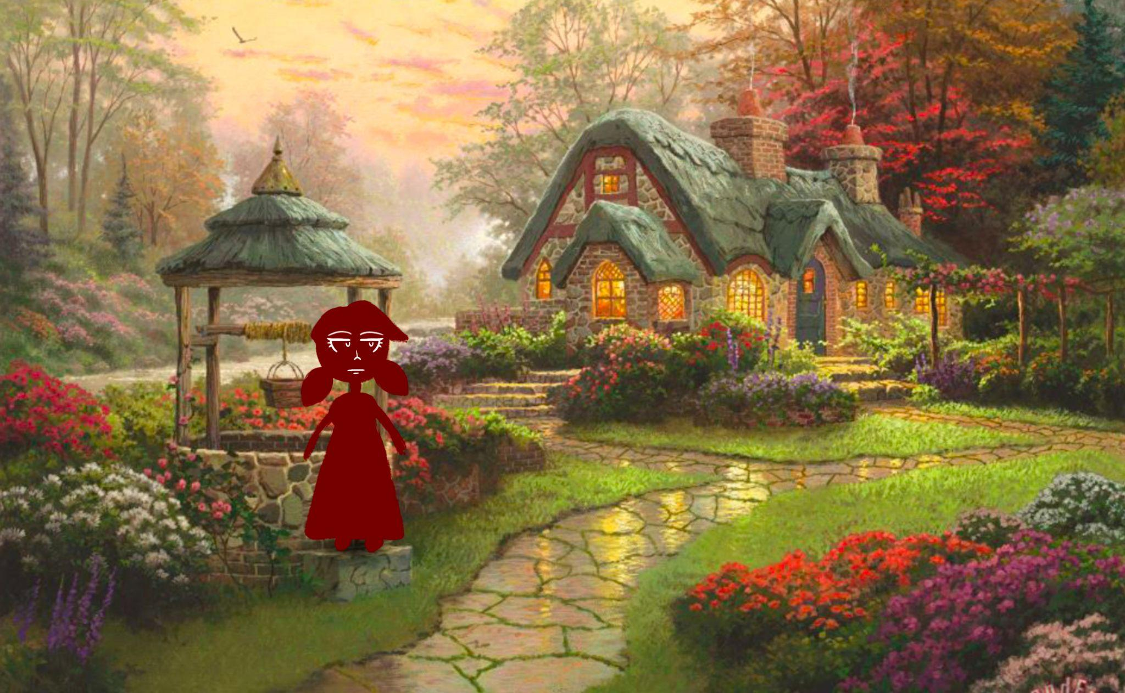
For the maiden however, with her curse broken, she felt like spring had come. Like the sky had parted and that the heavens shown down on her as dews from heaven. It was amazing how things had drastically changed.
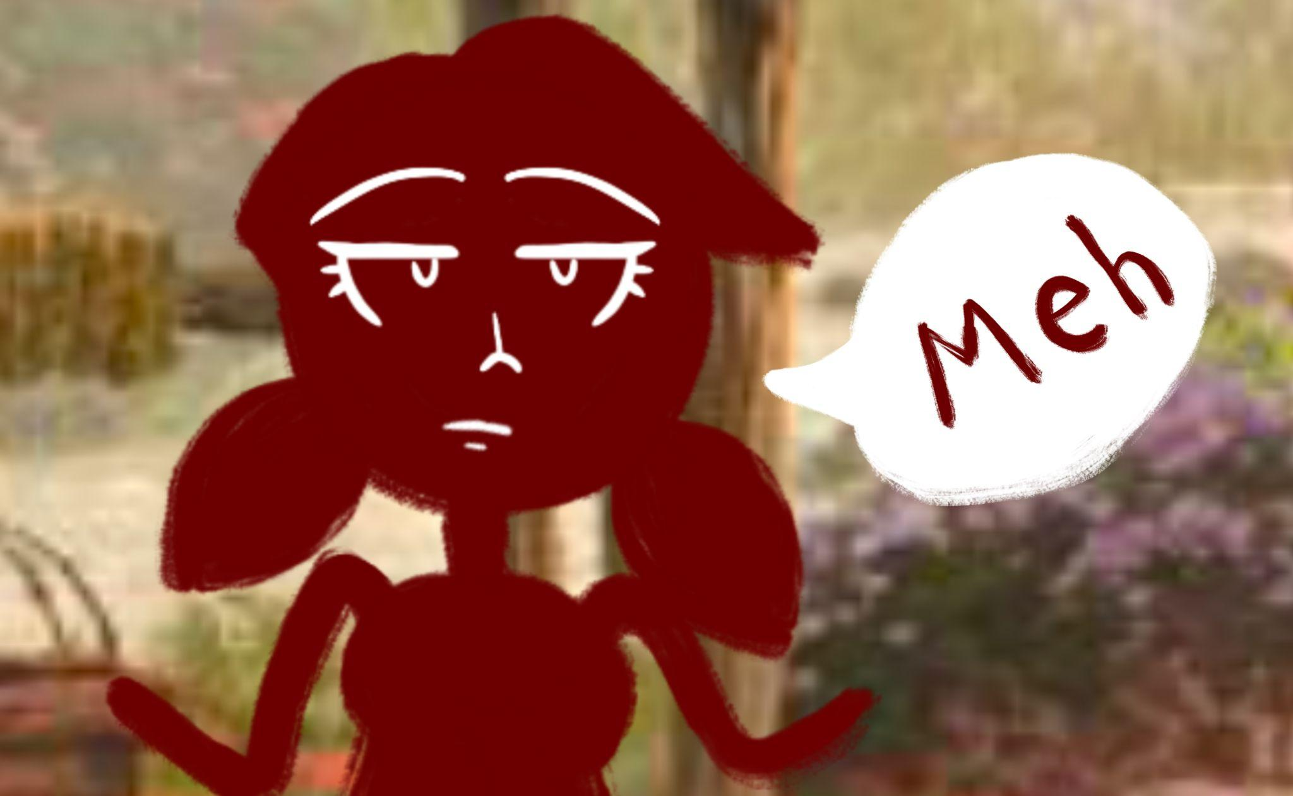
Well, actually the maiden basically completely disregarded the narrator’s words as she has done for the past 5 parts, so if she wants to tell the story, she’s welcome to, because apparently, the written words aren’t good enough for her.
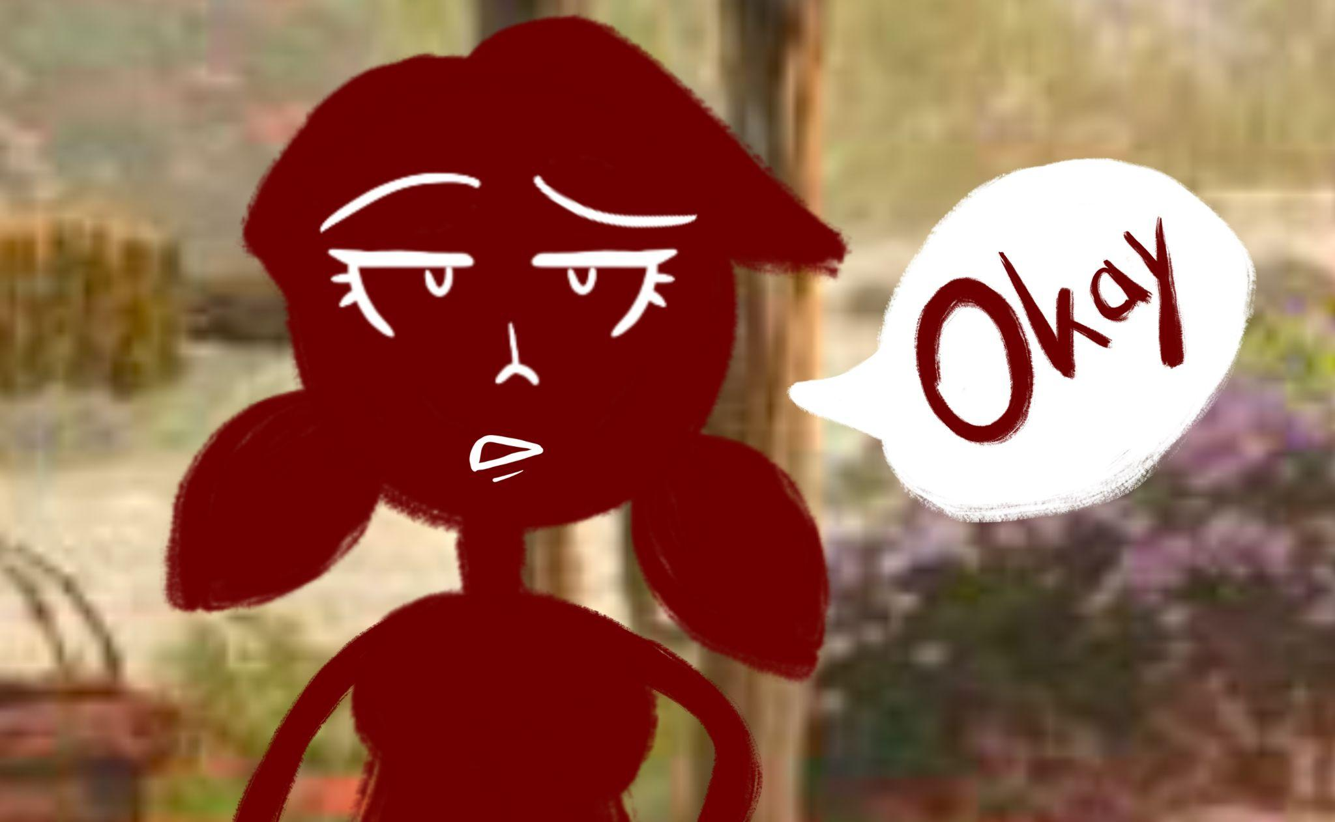

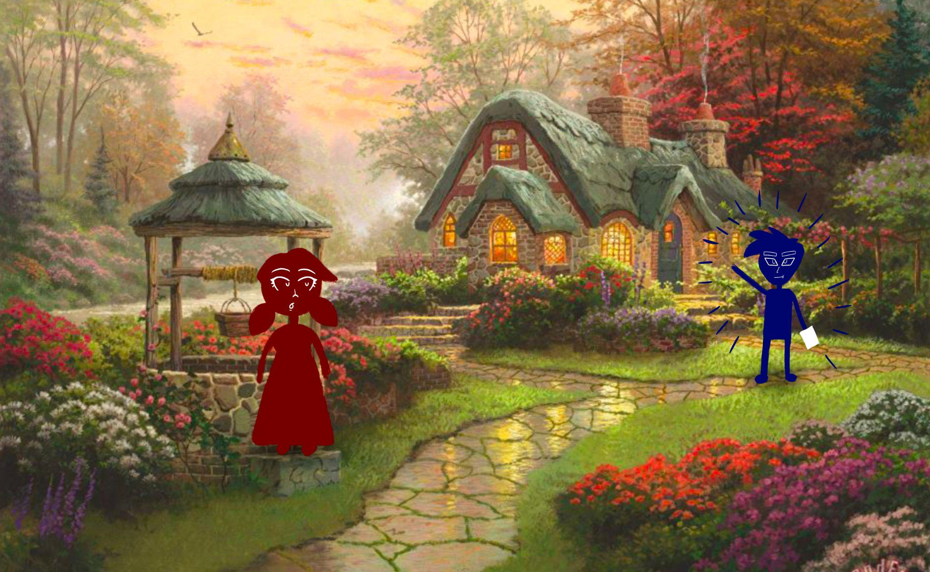
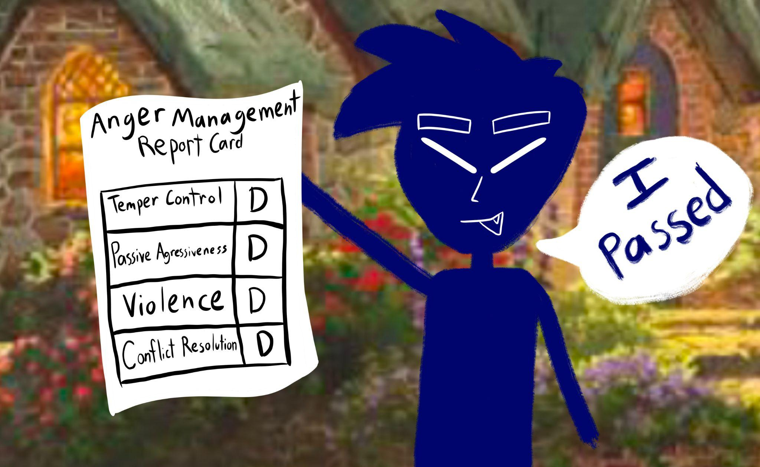
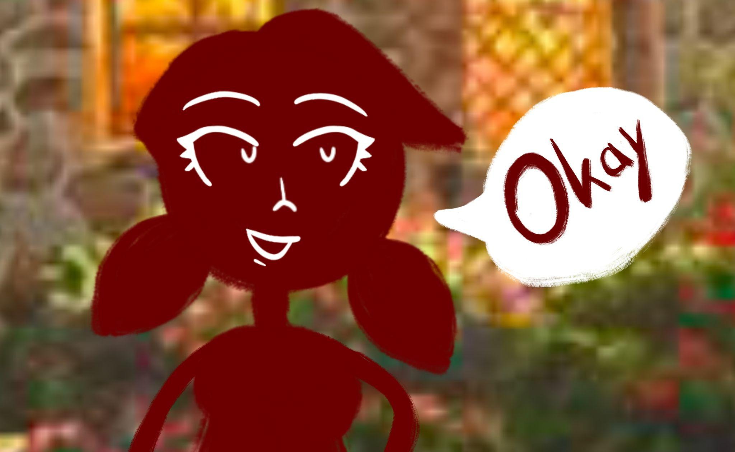
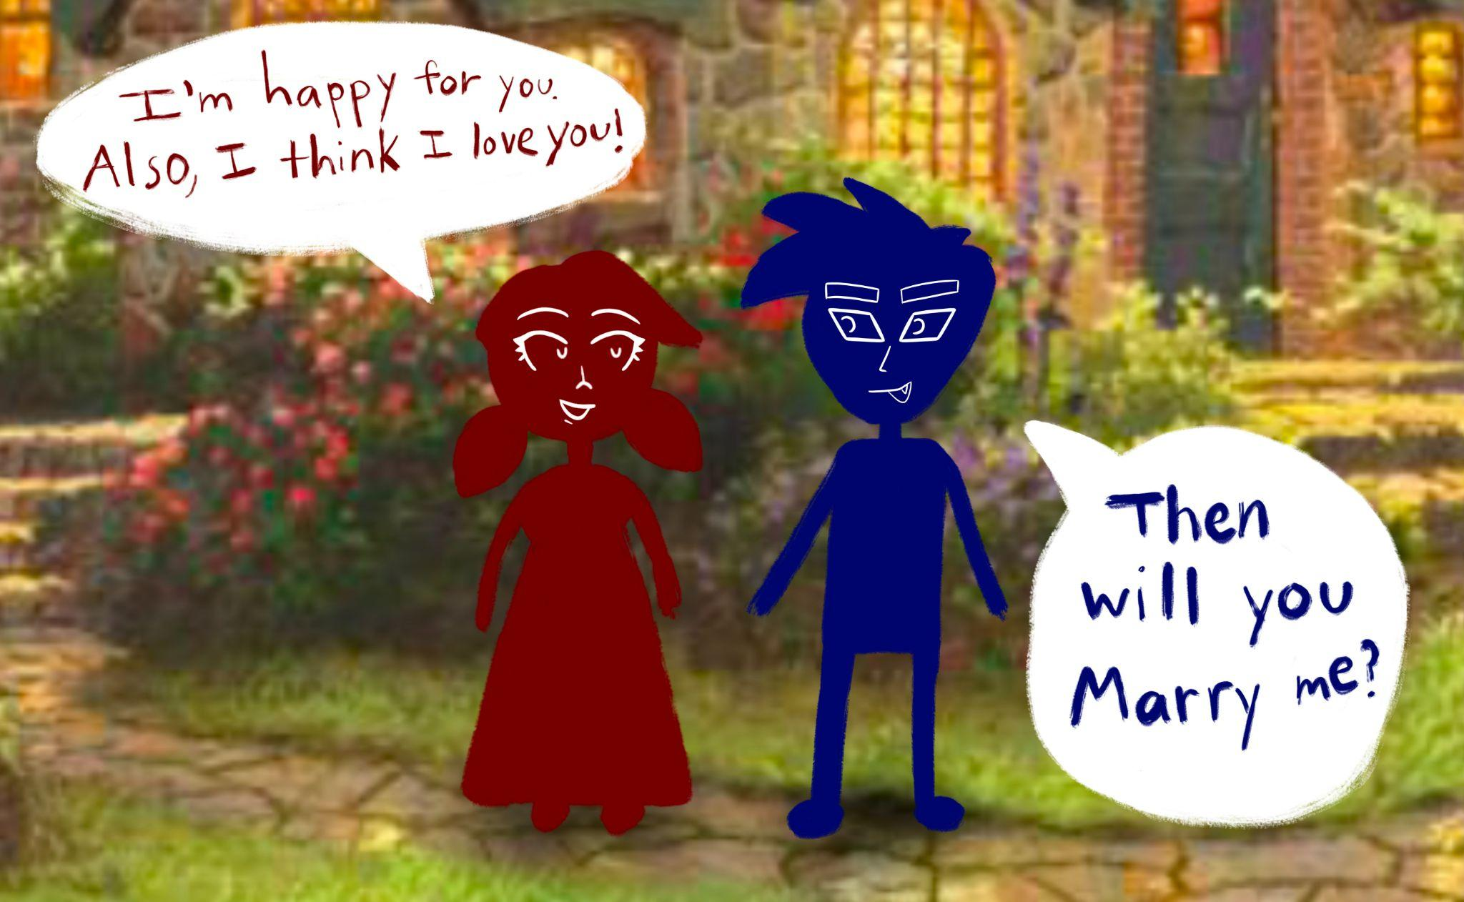
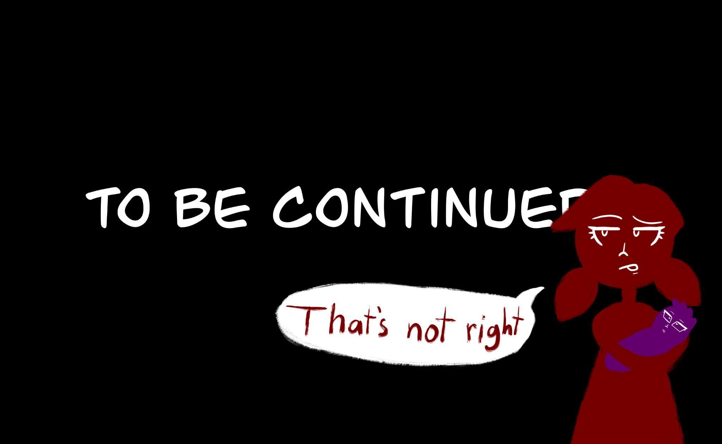

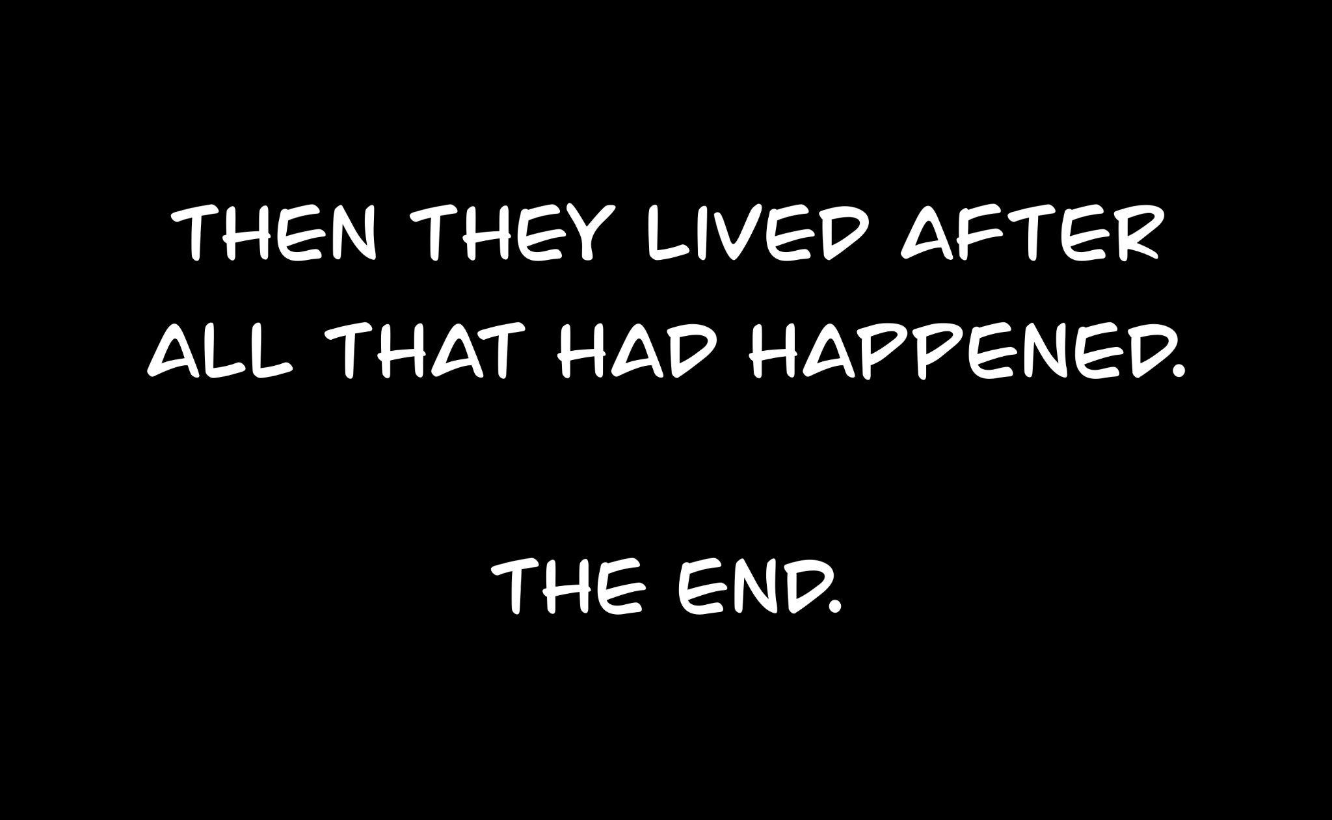

POETRY
CHERRY BLUE
Cherry blue hand soap on the corner of the stained kitchen sink
reminds me of that time we sat under the cherry blue sky.
We talked about my mother, and the stains she left
on the house when she forgot the dishes in the sink
and decided not to come back to finish them.
Cooked meat left clinging on rough unwashed plates. Then
we talked about your father and the time when he was teaching
you boxing. Only you were the punching bag and
he wasn’t teaching. Do you still remember
how he would sing you lullabies
in tones and shades of deep stringed orchestras
as if he hadn’t just done what he had done? Remember
how we used to say
we wouldn’t be like them. How
my lips would never
wear the same cherry lip gloss as her, and how
you would never have the same blue
bruised knuckles on age worn hands
Do you remember?
Can you still smell the cherry blue? Like
an ocean of fruit trees spread
over miles of forgotten-orchard lands. How
the winds take the scent on the breeze to blow
through like a tide that recedes
It comes.
It goes.
Like cherry blue promises
that feel as tough as steel.
Then you look to the surface and see
a glass reflection, smeared
by the oils of the hands that have touched it
stained by my dishes and
stained by your lullabies
How did we get here? Where
my lips are glossed cherry
and
your hands are bruised blue?

BLACK EYELASHES
His eyes are the windows
to palaces yet to be discovered. Yet,
on the roads to his architecture
there lies sentinels who dress his face
like the brush stroke of a painting.
Those long black eyelashes,
Miles of densely populated
gardened growth, cultivated
by the warmth of the sun
and a mother’s love.
They stand as thick forested trees yet
they flutter like the wings of a butterfly
silently flapping in reverent movement
like the bell of a church just
before the clapper joins to the bowl
with new vibration
The mysteries those shields protect
hidden away in darkened images
defined merely by the shape
of what could be

Lashes: Beautiful, Long, Thick, Dark
He is the envy of women everywhere

ESSAY
Emmalisa Horlacher, 13 Dec 2021
ENGL 218, Professor Budd
Saying Goodbye
I didn’t think I would come back to this topic. I definitely didn’t want to. Put bluntly, it’s hard to write about things that are hard. But like a tide that constantly rolls in and out, here I am. We like to avoid these kinds of subjects because they open up old wounds, rip open fresh tears. We’d rather not cry. Yet the truth is that we need it, I need it. I need to process it, everything that happened. I don’t need an audience; I just need to write.
My Grandpa, Joy Theadore Pearce, died September 19th, 2021. The doctors would say he died of COVID. My family would say he died from the effects of COVID but not to call it a COVID death because calling it a COVID death no longer makes him a person. It makes him into a statistic. The same statistic that is used to drive fear into the hearts of society. I don’t know what to say or what to call it. I knew that he was getting old. I knew that he got sick and tested positive with COVID. I knew he was in a kind of plateau state with lungs scarred from the effects of COVID. Then he died.
When my family had first heard the news that my Grandparents were sick with COVID we were all worried. We canceled the reunion and began saying our prayers. But what do we pray for? If he gets better, he’ll have to live with scarred lungs the rest of his life, spending more time, energy, and money on trying to survive another painful year. Is life even worth it at that point? Contrary, if he were to die he would go onto the next life, where he has long passed friends and family. He wouldn’t have to be in pain anymore. He would be able to know answers to questions he has long been asking, like what is heaven and will he remember a life before the one he lived here? At what point is it mercy to live, or mercy to die.
He lived a full life and I’ve always loved hearing stories about my Grandpa. How he grew up in a tiny town in Show Low Arizona, the youngest of ten. As the story goes, great-grandma Ione prayed for a boy after having seven girls in a row. With so many girls, it was finally a joy to have a boy and that’s how he got his name: Joy. A few years after he was born his father died, leaving his mother to raise the children by herself on a teacher’s salary. That woman, great-grandma Ione, is a legend in our family. As a young man Grandpa Joy served a two-year volunteer mission for his church. Religion was a big part of his life, just like how it is with mine. Those beliefs become something that connects us, from me to my parents, to him, to his parents and so on. It’s something that each of us had to choose but we chose it together. After his mission he started a construction company and married my Grandma after six weeks of knowing her. They were married for 0ver sixty years. I’d like to have a marriage like that, but maybe take a little longer to get to know the guy.
Grandpa Joy liked rodeos and was a fantastic team-roper, even getting to the world champion level. I remember looking at pictures of him at a rodeo riding on Risky, the best horse that a man could partner with. I remember opening the cattle guard to let the cows out so that he and his partner could practice.
He tried a semester or so of college but left that life to focus on being a farmer and concrete company owner. This route didn’t stop him from being successful in business. I asked him once what he did to be so successful. He said, “It’s the mindset. You have to think like the employer, not the employee.” Maybe he’s the reason I have a desire to start my own business. I remember later, we drove around Show Low and he pointed to different roads and parking lots and said, “I built that.” His company had revenue that went into the millions. Just another example of a millionaire college-dropout. He even bought a private plane, learned how to fly it, and used it to get certain parts for specific jobs he was working on. And if it broke, he would fix it. Cars, trucks, tractors, excavators, back-hoes, planes, he could fix just about anything. He was just that kind of guy.
I wish I knew more about the business but it tanked after handing it off to his children. As smart as he was, I think he had a weakness when it came to passing on that knowledge. He really was not a great teacher. Give him any situation, like hitching up a saddle; He’d say, “watch.” Then he’d hitch up the saddle and then he’d turn to you and say, “now you do it,” and then get frustrated when you didn’t know how to do it. Finally, he would just do it for you. I caught on real fast that you had to watch his every movement like a hawk and absorb everything he did like a sponge. And ask lots of questions, but not dumb questions cause then he’d say, “You should know that already.” I never learned to hitch a saddle, but I did learn how to hitch a trailer onto a truck.
His ranch was a cattle ranch, and he owned horses too. Beautiful black and white American Paints dotting the acres and acres of land. If he wasn’t working on his business, he was working on the ranch, riding his four-wheeler to mend fences, fill the salt-lickers, or blow-up prairie dogs. The cousins and I would wake up early just to see if we could get a ride with him across the fields. He’d pack three or four of us little ones on that orange four-wheeler and assign us each a job to open and close the big gates as we traveled around the ranch. He inherited that ranch from his mother. That’s the land where he raised his kids–where my mother grew up. The ranch is our homeland. We want to live and die on our homelands. But sometimes we don’t. Like when we die in hospital rooms. Empty and alone.
Grandpa Joy didn’t want to go to the hospital. He was afraid they would quarantine him and he would die alone. After going through quarantine myself, I didn’t want that for him either. Being in quarantine was like having the world pretend you don’t exist except for the few people who knew what you were going through. But even they couldn’t understand how painful it was to spend your birthday in a tiny apartment as you’re recovering from a panic attack brought on by fear of being enclosed inside for weeks. Not to mention the fact that everything felt sore and tired to the point that you almost passed out in the shower but you still had homework to do. Oh well. Oh well. You’re in quarantine and nobody cares about someone whining that they have to stay inside all day. It’s hard to be quarantined and everyone has their reasons why. I didn’t want my Grandpa to have to be quarantined. But his illness got worse and he had to go to the hospital. Quarantined at the hospital where the only people who could visit were the nurses who had hundreds of other patients. They didn’t know him. They didn’t have time for him. They weren’t there when he was teaching me to ride a bike. They weren’t there when he pointed out the jackrabbit so I could shoot my first animal with a gun. They weren’t there when I drove a 12-wheeler truck down a canyon as he guided me on what to do. I know it’s not their fault. I know they’re doing the best they can. But that doesn’t make it easier.
Grandma Beth was sick too, but she recovered. Due to regulations, she couldn’t visit him while he was in the hospital. She was hardly able to talk to him. The woman he’d been with for over 60 years. The woman who bore his children and helped him grow his business. The woman who made sure there was food ready when he came back to the house greasy and sore after working a tired day on the farm or business. She couldn’t even see him. She couldn’t be with him. When she called he tried to rally. He wanted to be strong for her. But he was sick. It took a caseworker to get the family to start thinking of “options” since it was a possibility that he wouldn't make it much longer. I didn’t even know what options meant. Did it mean he was going to spend the rest of his life with scarred lungs, where every breath feels like someone is scratching at your chest? Did it mean he was going to recover, that we would get to see him again? Did it mean we needed to start planning a funeral…
When someone is about to die, we don’t want to talk about it, but it feels like we have to. We use every word, every way we can to address it without ever really addressing it. It’s too hard to call it what it is. I remember I was on the phone with my mom walking to my car. We had been given messages from the hospital on and off about how he was improving, and then he’d get worse, and then he’d improve again. The most recent message was that he wasn’t doing well.
“Do you think Grandpa will get better?” I asked.
Do you think Grandpa will die?
“I think it might be time to start saying goodbye,” she said.
I think he will.
The hospital set up a video call for us. I don’t know if that made it better or worse. When we all jumped on the video call we could see him struggling in the hospital bed. He needed help but no one was coming. We had to call the hospital to notify the nurse that he needed help because no one was answering his call. Nobody was there. He had over 16 children including in-laws, over a hundred grandchildren. And none of them could visit. We could all only watch through a flat, lonely video screen as we saw the image of our rodeo-world-champion millionaire cowboy Grandfather laying flat on his bed, tubes sticking out of his arms and an oxygen mask covering his face. We could only watch. We’d try to say something, we couldn’t tell if he could hear us. He’d try to say something, over the sounds of all the machines in his room, we couldn’t hear him. We would’ve asked the nurse if she could tell us what he was saying. What were his last words to us? What does he want us to know? But she couldn’t. She had other patients to attend to. And she wasn’t there.
We tried to be there over the video call. There was always at least one person on, otherwise the hospital would have turned it off. Yet, everytime we joined, it was like we were gearing up to say goodbye. Goodbye. But what is a goodbye over a video call? It’s emptiness. You can’t lift up their cold hand and reassure them that you’re there. You can’t hug them. You can’t lean in close to hear the words they struggle to say. You can only watch.
Then it was September 19th and because of the seriousness of his condition the hospital allowed Grandma Beth and a few of their kids to visit. They had her clad up in protective gear, a full body shield. I heard the full story from her later. He was lying there, no longer trying to be strong. All he was saying was, “help me, help me, help me.” My tender hearted Grandma had to watch as he suffered in bed before her eyes with nothing she could do for him. Finally she said, “I don’t know how to help you.” Then she told him that it was okay to move on. Then she left. She had to tell that story again and again to every family member that asked. Me included.
I was at my sister’s house when it happened. It was me, her, her husband, and their son Todd, surrounding their dell computer. My mom sent a text, “Grandpa is not doing good. You can get on and see him. The new ID # is…”
So we jumped on the video call. He was lying there. No tubes. No oxygen mask. He had a wrinkled face from smiling, laughing and singing with family. Big round glasses and hearing aids which never stopped him from asking people to speak louder. He had a wispy full head of white hair. He still had that indent in his nose from when he used black salve to draw the cancer out. Or at least I think the indent was still there. I really couldn’t see specifics through the pixelated video screen. He was just an old guy. Just an old man lying on the bed. But he wasn’t just any old man. He was my Grandpa. From the screen we really couldn’t tell if he was breathing or if he could hear us. He was so still.
The family didn’t think it would happen so soon. On the call, a few of us grandkids start taking turns singing to him. My sister and I sang, “I’ll Go Where You Want Me To Go.” Grandpa loved it when we all sang together but the audio system only worked if one device was singing at a time. So we took turns, singing along only if we were muted. Then the nurse came into the room. We asked how he was doing and the nurse turned to us and said, “Oh, uh, he died thirty minutes ago.”
We started crying.
I wanted to leave.
No one was there with him when he passed. I had hoped to be able to hear his last story, his last testimony, his last words. I had hoped to be able to see him at the reunion. I had hoped to get to drive a truck with him again. I had hoped that he would be there at my wedding and tell his silly stories to embarrass me. But he wouldn’t. Not anymore. He wasn’t there. He died in a hospital room, probably while we sang to him. Some could say that we were there in spirit or in song or in the only way we could. Maybe that’s true. But I also think it was the worst way to say goodbye, on a flat, lonely, video screen. And then we started planning the funeral.
My sister wasn’t able to come to the funeral, being 8 months pregnant as she was, but in the middle of the night, she awoke and had a feeling that she needed to read her scriptures; That Grandpa was trying to reach her. She wanted to go back to bed but she felt that if she wouldn’t listen, Grandpa would go find someone who would. So she pulled out her scriptures and found Mosiah 2:14-17 and 41, “consider on the blessed and happy state of those that keep the commandments.” It was as if those scriptures were the final words to us that he never got to speak. I needed those words. They were his testimony. A testimony that I too, know to be true. And of course Grandpa Joy includes the words “happy” in his testimony. He always loved plays on words that related to his name. My sister shared those thoughts with my mom before the week of the funeral.
I left on Friday to drive down with my brother and his family for the funeral. I looked in his casket at a man much thinner than the one I remember my Grandpa being. Grandma Beth said he lost weight and that the funeral house had him looking so nice and good. But to me he didn’t look like my Grandpa. He looked like a stiff body and I wondered if dead men could ever really look good.
It was a nice funeral. The family sang and gave speeches. We took pictures by the casket at the burial site. There were lots of little kids running around, laughing and playing. My family doesn’t really have sad funerals. We can be sad at funerals, but because we believe that we will see him again, it doesn’t feel so final. Funerals then become just a way to celebrate the lives of the people we loved.
When I came back from the funeral, I had recently moved into a new apartment and my roommates were talking about masks and COVID. One of them had a friend whose uncle died of COVID and the friend didn’t even wear a mask at the funeral.
I thought about how I didn’t wear a mask at the funeral. I didn’t think Grandpa would have wanted me to. Almost none of the family wore a mask.
My roommates said, “His uncle just died of COVID and he still wasn’t wearing a mask. Was he still not taking COVID seriously?”
I didn’t say anything to them. I just left, called my mom and cried to her, asking if I was a bad person for not wearing a mask at my own Grandfather’s funeral. As if my actions had somehow made a mockery of his death. I think I understood why my family didn’t want his death to be a COVID death; My Grandpa was defined by more than just his death. He had lived an amazing and honorable life and I wish his life meant more to statistics than his death did. I don’t want him to be remembered as just another old person who died during COVID. He was more than that.
When I first started writing, a lot of what I put down was in present tense. My grandpa was suffering before my eyes. My family was suffering. It was a current event. Now it’s not. Now the event has passed. The funeral has passed. All those feelings of anger and frustration, they pass too. I don’t know if all of them are gone, but it doesn’t feel so sharp anymore. Funny how time seems to cool down angry tides.
There’s a family song on the Pearce side and even though I don’t have Pearce for my last name I sing it anyway. So many memories accompany that song. Like singing it in the green bus on family vacations, or singing as we’re gathered around a giant thanksgiving feast, and now, having sung it at my Grandpa’s funeral. A line in the chorus goes, “happiness is here with you.” There it is, another word play on his name; happiness, joy. It makes me wonder though, if now that he’s gone, have I lost joy? But no, it doesn’t feel like that. Strangely enough, it doesn’t feel like he’s gone. I suppose I assumed that there would be this feeling like an empty hole left in the world but honestly, it just doesn’t feel like he left. I feel like I can still sense his presence, even stronger now than when he was alive. It’s an odd feeling. Like he is watching over me and my family, like joy will always be with us.
While no one was in the room with him when he passed, I like to think, maybe God sent him angels to be there with him and to guide him to heaven. Maybe he got to see his mother and his sisters and the father who died before he ever really got to know him. Maybe he’ll be able to get to know him in Heaven. Maybe Christ himself came to welcome him home and tell him how loved he is. Maybe when he said goodbye here, he got to say “hello again” to so many others there. At least, that’s what I hope. That’s what I prayed for. I love my Grandpa. And while I say goodbye now, I look forward to the day when I get to say hello again.

